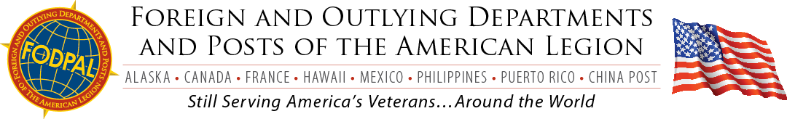

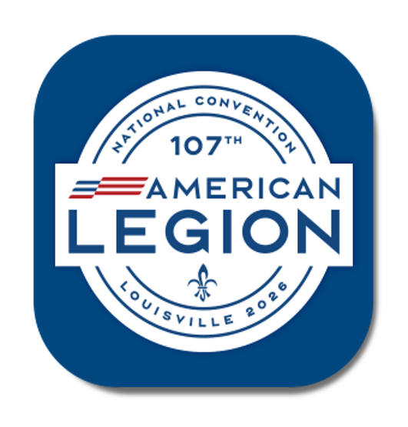
COME ONE COME ALL TO THE
FODPAL
ANNUAL NATIONAL CONVENTION
BREAKFAST / INSTALLATION

PLACE: Galt House, Breathitt, 2nd Floor, East Tower

DATE: August 31, 2026 TIME: 0700hrs SHARP

COST: $40.00 per Person

This is the biggest event of the year for FODPAL. It has become “The Showcase” of the National Convention. So, pass the word to all of your Members that are going to attend the National Convention.

Pre-Reservations will help us; this will give me a good estimate of the number of people that will be attending.

Tickets will be issued at the Convention Site starting on Saturday August 29th.

Adjutants, Commanders, or NECman do not forget to bring some items from your Department for the RAFFLE that is held after breakfast.
---------------------------------------------------------------------------------------------------------------------------------------
RESERVATION REQUEST

Enclosed is a check in the amount of $__________for_________reservation tickets

MAKE CHECKS PAYABLE TO FODPAL
AND MAIL TO:

Doug Haggan
5712 Riva Ridge DR.
Indianapolis, IN 46237

