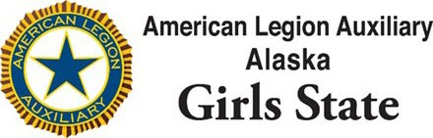

Citizen Application
Date: June 1-7, 2024
Application Deadline April 1, 2024

Personal Information
Name:

Date:

High School: Age: Shirt Size:

Email:
(Please provide a home email address. School email addresses will not be accepted).
Address:
Phone:

Parent Information
Parent/ Legal Guardian name:

Address

Phone Number:

Email address:

Are you a legal US Citizen? ☐ yes ☐ no
If you are not a LEGAL US CITIZEN, you must provide documentation of legal inhabitants. Are you able to provide this documentation? ☐Yes ☐ No ☐ n/a

Are you currently a Junior in High School? Yes No
☐

Personal Interests: Please tell us a little bit about yourself and what you have done during your high school career by answering the following questions:

What offices have you held in any High School Organizations?

List any other activities that you participate or have participated in outside of school.

List your hobbies and/or interests.

Please briefly explain why you want to attend American Legion Auxiliary Alaska Girls State.

Why are you the best candidate to attend the American Legion Auxiliary Alaska Girls State program?

Please provide two personal references:
Name
Phone Number

Name
Phone Number

____________________________
Signature Date

